IT24100008

**Question 01**

i.

ii.

**Question 02**

i.

ii.

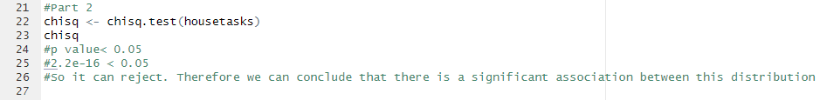

**Exercise**

